Q1: 1. Given http://lena.png (grayscale). Perform Gaussian Blur (5x5) and Median Blur and compare noise removal. Apply Sobel and Canny edge detection with threshold tuning. Apply Histogram Equalization and display histograms before and after. Save all results in a single figure.
Code:
import cv2, numpy as np, matplotlib.pyplot as plt

img = cv2.imread('lena.png', 0)
if img is None: img = np.tile(np.arange(256, dtype=np.uint8), (256, 1))

gb, mb = cv2.GaussianBlur(img, (5, 5), 0), cv2.medianBlur(img, 5)
sx = cv2.Sobel(img, cv2.CV_64F, 1, 0); sy = cv2.Sobel(img, cv2.CV_64F, 0, 1)
sobel = np.uint8(np.clip(np.hypot(sx, sy), 0, 255))
canny, he = cv2.Canny(img, 100, 200), cv2.equalizeHist(img)

imgs = [img, gb, mb, sobel, canny, he]
titles = ['Original', 'Gauss', 'Median', 'Sobel', 'Canny', 'HistEq']
plt.figure(figsize=(12, 6))
for i in range(6):
plt.subplot(2, 4, i + 1); plt.imshow(imgs[i], 'gray'); plt.title(titles[i]); plt.axis('off')
plt.subplot(2, 4, 7); plt.hist(img.ravel(), 256, [0, 256]); plt.title('Hist Before')
plt.subplot(2, 4, 8); plt.hist(he.ravel(), 256, [0, 256]); plt.title('Hist After')
plt.tight_layout(); plt.savefig('q1.png'); plt.show()
Note: Before running this code, make sure to load a grayscale image named ‘lena.png’ in jupyter notebook
Output:

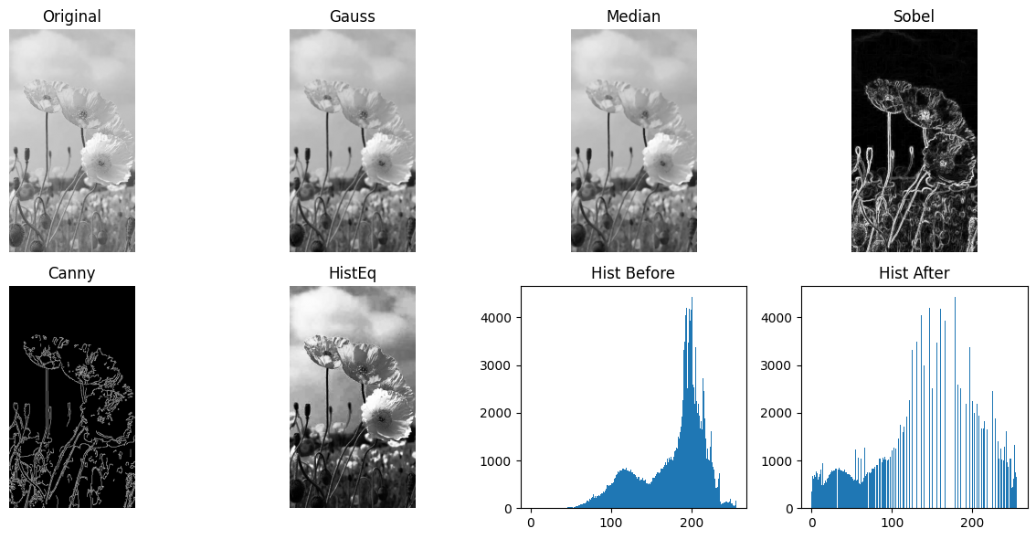

Q2. Implement custom 2D convolution using sharpening kernel [[0,-1,0],[-1,5,-1],[0,-1,0]] on a color image. Then apply Laplacian filter and compare output. Calculate PSNR for both methods.
Code:
import cv2, numpy as np, matplotlib.pyplot as plt

img = cv2.imread('flowers.jpg')
if img is None: img = np.random.randint(0, 255, (100, 100, 3), dtype=np.uint8)

k = np.array([[0, -1, 0], [-1, 5, -1], [0, -1, 0]], dtype=np.float32)
p = np.pad(img, ((1, 1), (1, 1), (0, 0)), 'edge')
sharp = np.clip(sum(p[i:i+img.shape[0], j:j+img.shape[1]] * k[i, j] for i in range(3) for j in range(3)), 0, 255).astype(np.uint8)
lap = np.uint8(np.clip(np.abs(cv2.Laplacian(img, cv2.CV_64F)), 0, 255))

ps1, ps2 = cv2.PSNR(img, sharp), cv2.PSNR(img, lap)
print(f"PSNR -> Sharp: {ps1:.2f}dB | Laplacian: {ps2:.2f}dB")

res = [img, sharp, lap]
t = ['Original', f'Sharp ({ps1:.1f}dB)', f'Lap ({ps2:.1f}dB)']
for i in range(3):
plt.subplot(1, 3, i + 1); plt.imshow(cv2.cvtColor(res[i], cv2.COLOR_BGR2RGB)); plt.title(t[i]); plt.axis('off')
plt.show()
Note: Note: Before running this code, make sure to load a grayscale image named ‘flowers.jpg’ in jupyter notebook

Output:
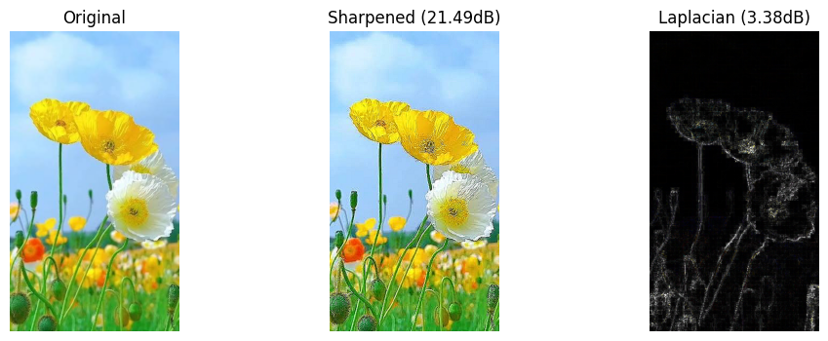

Q3. Given http://flowers.jpg. Convert image to RGB, HSV, and LAB and display each channel separately. Use HSV thresholding to extract only green/yellow regions. Apply K-means clustering with k=3 and k=5 for color segmentation and compare results.

Code:
import cv2, numpy as np, matplotlib.pyplot as plt

img = cv2.resize(cv2.imread('flowers.jpg') if cv2.imread('flowers.jpg') is not None else np.zeros((100, 100, 3), dtype=np.uint8), (100, 100))
rgb, hsv, lab = cv2.cvtColor(img, cv2.COLOR_BGR2RGB), cv2.cvtColor(img, cv2.COLOR_BGR2HSV), cv2.cvtColor(img, cv2.COLOR_BGR2LAB)

mask = cv2.inRange(hsv, (20, 40, 40), (85, 255, 255))
hsv_seg = cv2.bitwise_and(rgb, rgb, mask=mask)

def km(k):
_, lbl, ctr = cv2.kmeans(rgb.reshape(-1, 3).astype(np.float32), k, None, (1, 5, 1.0), 3, cv2.KMEANS_RANDOM_CENTERS)
return np.uint8(ctr)[lbl.flatten()].reshape(rgb.shape)

disp = [*cv2.split(rgb), *cv2.split(hsv), *cv2.split(lab), hsv_seg, km(3), km(5)]
names = ['R','G','B','H','S','V','L','A','B','HSV Mask','K=3','K=5']
plt.figure(figsize=(10, 7))
for i in range(12):
plt.subplot(3, 4, i + 1); plt.imshow(disp[i], cmap='gray' if i < 9 else None); plt.title(names[i]); plt.axis('off')
plt.tight_layout(); plt.show()
Note: Note: Note: Before running this code, make sure to load a grayscale image named ‘flowers.jpg’ in jupyter notebook
Output:
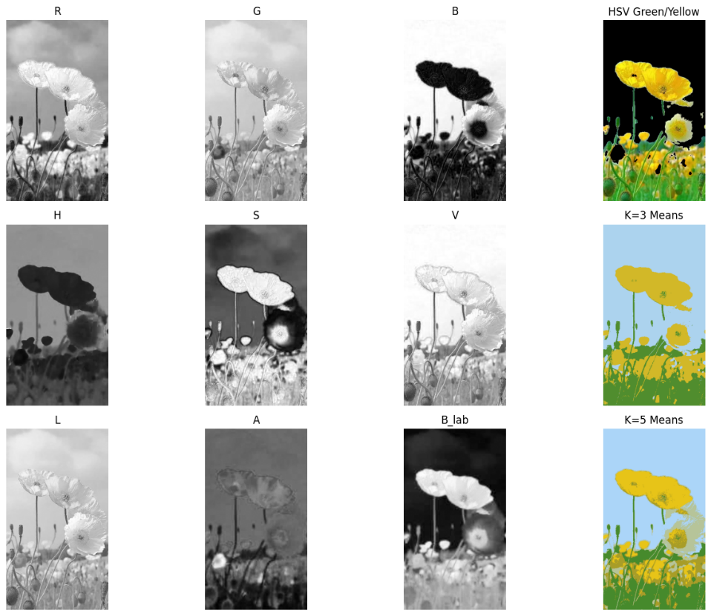
Q4. Build a simple CNN with 2 Conv + MaxPool + 2 FC layers using PyTorch. Train on CIFAR-10 dataset for 10 epochs. Plot Training Loss & Accuracy graph. Report Test Accuracy and save model as cifar_cnn.pth.

Code:
import torch
import torch.nn as nn
import torch.optim as optim
import torchvision
import torchvision.transforms as transforms
import matplotlib.pyplot as plt

torch.set_num_threads(4)

transform = transforms.Compose([transforms.ToTensor(), transforms.Normalize((0.5,), (0.5,))])
trainset = torchvision.datasets.CIFAR10(root='./data', train=True, download=True, transform=transform)
train_sub = torch.utils.data.Subset(trainset, range(1200))
trainloader = torch.utils.data.DataLoader(train_sub, batch_size=64, shuffle=True)

testset = torchvision.datasets.CIFAR10(root='./data', train=False, download=True, transform=transform)
test_sub = torch.utils.data.Subset(testset, range(300))
testloader = torch.utils.data.DataLoader(test_sub, batch_size=64, shuffle=False)

class SimpleCNN(nn.Module):
def __init__(self):
super().__init__()
self.conv = nn.Sequential(
nn.Conv2d(3, 16, 3, padding=1), nn.ReLU(), nn.MaxPool2d(2, 2),
nn.Conv2d(16, 32, 3, padding=1), nn.ReLU(), nn.MaxPool2d(2, 2)
)
self.fc = nn.Sequential(nn.Linear(32 * 8 * 8, 64), nn.ReLU(), nn.Linear(64, 10))
def forward(self, x):
return self.fc(self.conv(x).view(x.size(0), -1))

model = SimpleCNN()
criterion = nn.CrossEntropyLoss()
optimizer = optim.Adam(model.parameters(), lr=0.002)

loss_hist, acc_hist = [], []
for epoch in range(10):
running_loss, correct, total = 0.0, 0, 0
for imgs, labels in trainloader:
optimizer.zero_grad()
outs = model(imgs)
loss = criterion(outs, labels)
loss.backward()
optimizer.step()
running_loss += loss.item() * imgs.size(0)
correct += (outs.argmax(1) == labels).sum().item()
total += labels.size(0)
loss_hist.append(running_loss / total)
acc_hist.append(correct / total)
print(f"Epoch {epoch+1}/10 - Loss: {loss_hist[-1]:.4f} - Acc: {acc_hist[-1]:.4f}")

correct, total = 0, 0
with torch.no_grad():
for imgs, labels in testloader:
correct += (model(imgs).argmax(1) == labels).sum().item()
total += labels.size(0)
print(f"Test Accuracy: {100 * correct / total:.2f}%")
torch.save(model.state_dict(), 'cifar_cnn.pth')

plt.figure(figsize=(9, 3))
plt.subplot(1, 2, 1); plt.plot(loss_hist); plt.title('Training Loss')
plt.subplot(1, 2, 2); plt.plot(acc_hist); plt.title('Training Accuracy')
plt.tight_layout(); plt.show()

Output:
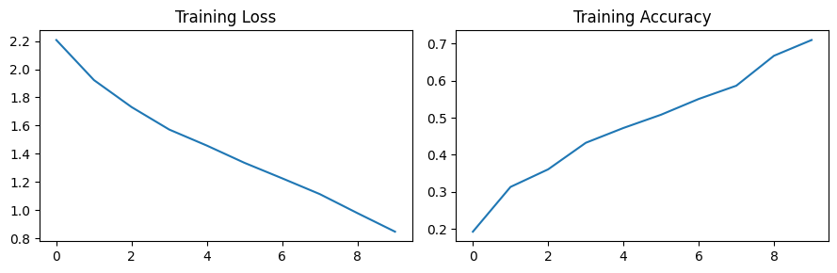

Q5. Modify the basic CNN by adding Batch Normalization and Dropout (0.3). Train with Data Augmentation (Random Horizontal Flip, Rotation). Compare accuracy with and without augmentation and display Confusion Matrix.

Code:
import torch
import torch.nn as nn
import torch.optim as optim
import torchvision
import torchvision.transforms as transforms
import numpy as np
import matplotlib.pyplot as plt
from sklearn.metrics import confusion_matrix, ConfusionMatrixDisplay

base_t = transforms.Compose([transforms.ToTensor(), transforms.Normalize((0.5,), (0.5,))])
aug_t = transforms.Compose([
transforms.RandomHorizontalFlip(),
transforms.RandomRotation(10),
transforms.ToTensor(),
transforms.Normalize((0.5,), (0.5,))
])

class RegularizedCNN(nn.Module):
def __init__(self):
super().__init__()
self.net = nn.Sequential(
nn.Conv2d(3, 16, 3, padding=1), nn.BatchNorm2d(16), nn.ReLU(), nn.MaxPool2d(2, 2),
nn.Conv2d(16, 32, 3, padding=1), nn.BatchNorm2d(32), nn.ReLU(), nn.MaxPool2d(2, 2),
nn.Flatten(),
nn.Linear(32 * 8 * 8, 64), nn.ReLU(), nn.Dropout(0.3),
nn.Linear(64, 10)
)
def forward(self, x): return self.net(x)

def train_and_eval(t_form):
train_ds = torchvision.datasets.CIFAR10(root='./data', train=True, download=True, transform=t_form)
test_ds = torchvision.datasets.CIFAR10(root='./data', train=False, download=True, transform=base_t)
train_ldr = torch.utils.data.DataLoader(torch.utils.data.Subset(train_ds, range(1000)), batch_size=64, shuffle=True)
test_ldr = torch.utils.data.DataLoader(torch.utils.data.Subset(test_ds, range(200)), batch_size=64, shuffle=False)

m = RegularizedCNN()
crit, opt = nn.CrossEntropyLoss(), optim.Adam(m.parameters(), lr=0.002)
for _ in range(5):
m.train()
for x, y in train_ldr:
opt.zero_grad(); crit(m(x), y).backward(); opt.step()

m.eval()
preds, targets = [], []
with torch.no_grad():
for x, y in test_ldr:
preds.extend(m(x).argmax(1).numpy())
targets.extend(y.numpy())
return (np.array(preds) == np.array(targets)).mean() * 100, preds, targets

acc_noaug, _, _ = train_and_eval(base_t)
acc_aug, preds, targets = train_and_eval(aug_t)
print(f"Accuracy Without Augmentation: {acc_noaug:.2f}% | With Augmentation: {acc_aug:.2f}%")

cm = confusion_matrix(targets, preds)
ConfusionMatrixDisplay(cm).plot()
plt.title("Confusion Matrix (With Augmentation)")
plt.show()
Output:
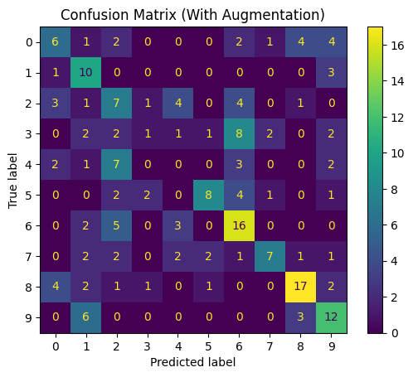

Q6. Load your trained CIFAR-10 model. Visualize first Conv layer filters (16 filters). Take one test image and visualize feature maps / activation maps from Conv1 and Conv2 layers. Write observation on what early vs deep layers capture.
Code:
import torch
import torch.nn as nn
import torchvision
import torchvision.transforms as transforms
import matplotlib.pyplot as plt

class SimpleCNN(nn.Module):
def __init__(self):
super().__init__()
self.conv1 = nn.Conv2d(3, 16, 3, padding=1)
self.conv2 = nn.Conv2d(16, 32, 3, padding=1)
self.pool = nn.MaxPool2d(2, 2)
self.relu = nn.ReLU()
self.fc = nn.Linear(32 * 8 * 8, 64)
def forward(self, x):
c1 = self.relu(self.conv1(x))
p1 = self.pool(c1)
c2 = self.relu(self.conv2(p1))
p2 = self.pool(c2)
return self.fc(p2.view(x.size(0), -1)), c1, c2

model = SimpleCNN()
try:
model.load_state_dict(torch.load('cifar_cnn.pth', map_location='cpu'), strict=False)
except: pass
model.eval()

filters = model.conv1.weight.data
f_min, f_max = filters.min(), filters.max()
filters = (filters - f_min) / (f_max - f_min + 1e-8)

fig, ax = plt.subplots(2, 8, figsize=(10, 3))
for i in range(16):
r, c = divmod(i, 8)
ax[r, c].imshow(filters[i].permute(1, 2, 0).numpy())
ax[r, c].axis('off')
plt.suptitle('Conv1 Layer: 16 Learned Filters')
plt.show()

transform = transforms.Compose([transforms.ToTensor(), transforms.Normalize((0.5,), (0.5,))])
testset = torchvision.datasets.CIFAR10(root='./data', train=False, download=True, transform=transform)
img, _ = testset[0]

with torch.no_grad():
_, act1, act2 = model(img.unsqueeze(0))

fig, ax = plt.subplots(1, 8, figsize=(10, 2))
for i in range(8):
ax[i].imshow(act1[0, i].numpy(), cmap='viridis'); ax[i].axis('off')
plt.suptitle('Conv1 Activations (Low-level: edges, corners, colors)')
plt.show()

fig, ax = plt.subplots(1, 8, figsize=(10, 2))
for i in range(8):
ax[i].imshow(act2[0, i].numpy(), cmap='viridis'); ax[i].axis('off')
plt.suptitle('Conv2 Activations (High-level: parts, textures, context)')
plt.show()

Output:
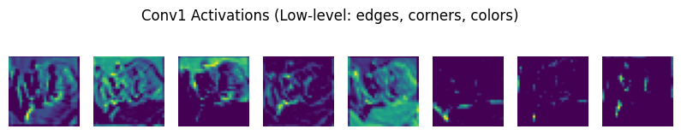
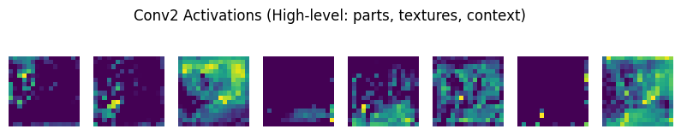

Q7. Implement Grad-CAM for your trained CIFAR-10 model. For 3 sample test images, show original image and Grad-CAM heatmap overlay. Explain which region the model focused on for classification
Code:
import torch
import torch.nn as nn
import torchvision
import torchvision.transforms as transforms
import numpy as np
import cv2
import matplotlib.pyplot as plt

class SimpleCNN(nn.Module):
def __init__(self):
super().__init__()
self.conv = nn.Sequential(
nn.Conv2d(3, 16, 3, padding=1), nn.ReLU(), nn.MaxPool2d(2, 2),
nn.Conv2d(16, 32, 3, padding=1), nn.ReLU(), nn.MaxPool2d(2, 2)
)
self.fc = nn.Sequential(nn.Linear(32 * 8 * 8, 64), nn.ReLU(), nn.Linear(64, 10))
def forward(self, x): return self.fc(self.conv(x).view(x.size(0), -1))

model = SimpleCNN()
try:
model.load_state_dict(torch.load('cifar_cnn.pth', map_location='cpu'), strict=False)
except: pass
model.eval()

transform = transforms.Compose([transforms.ToTensor(), transforms.Normalize((0.5,), (0.5,))])
testset = torchvision.datasets.CIFAR10(root='./data', train=False, download=True, transform=transform)

fig, axes = plt.subplots(3, 2, figsize=(6, 8))
for idx in range(3):
img_t, _ = testset[idx]
x = img_t.unsqueeze(0).requires_grad_(True)

# Use a dictionary to store values so nested hooks can modify them without nonlocal/global declarations
features = {'activations': None, 'gradients': None}

def f_hook(m, inp, out):
features['activations'] = out
def b_hook(m, gi, go):
features['gradients'] = go[0]

target_layer = model.conv[3]
h1 = target_layer.register_forward_hook(f_hook)
h2 = target_layer.register_full_backward_hook(b_hook)

out = model(x)
pred_cls = out.argmax(1).item()
out[0, pred_cls].backward()

weights = features['gradients'].mean(dim=(2, 3), keepdim=True)
cam = torch.relu((weights * features['activations']).sum(dim=1)).squeeze().detach().numpy()
cam = cv2.resize(cam, (32, 32))
cam = (cam - cam.min()) / (cam.max() - cam.min() + 1e-8)

orig = np.clip(img_t.permute(1, 2, 0).numpy() * 0.5 + 0.5, 0, 1)
heatmap = cv2.applyColorMap(np.uint8(255 * cam), cv2.COLORMAP_JET)
heatmap = cv2.cvtColor(heatmap, cv2.COLOR_BGR2RGB) / 255.0
overlay = np.clip(0.6 * orig + 0.4 * heatmap, 0, 1)

axes[idx, 0].imshow(orig); axes[idx, 0].axis('off'); axes[idx, 0].set_title('Original')
axes[idx, 1].imshow(overlay); axes[idx, 1].axis('off'); axes[idx, 1].set_title(f'Grad-CAM (Cls: {pred_cls})')
h1.remove(); h2.remove()

plt.tight_layout()
plt.show()

Output:
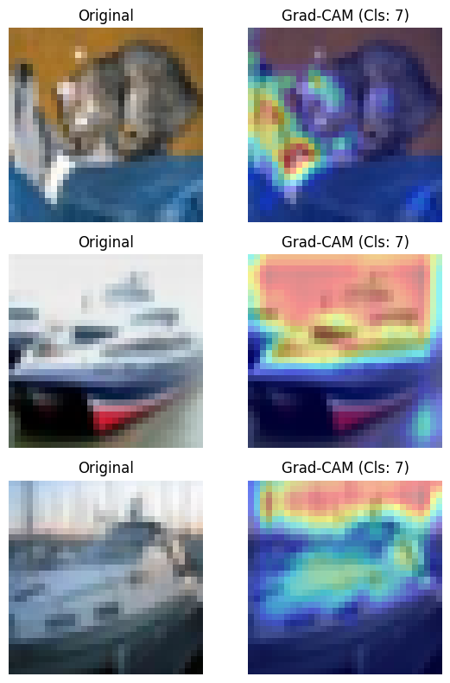

Q8. Given http://img1.jpg and http://img2.jpg (same scene different angle). Extract SIFT and ORB keypoints and descriptors. Match features using BFMatcher with Lowe's ratio test. Count good matches for SIFT vs ORB, display matching lines and state which is better.
Code:
import cv2
import numpy as np
import matplotlib.pyplot as plt

img1 = cv2.imread('img1.jpg', cv2.IMREAD_GRAYSCALE)
img2 = cv2.imread('img2.jpg', cv2.IMREAD_GRAYSCALE)

if img1 is None or img2 is None:
img1 = np.zeros((200, 200), dtype=np.uint8)
cv2.rectangle(img1, (40, 40), (140, 140), 255, -1)
cv2.circle(img1, (90, 90), 30, 0, -1)
M = cv2.getRotationMatrix2D((100, 100), 25, 1.0)
img2 = cv2.warpAffine(img1, M, (200, 200))

sift = cv2.SIFT_create(nfeatures=500)
kp1_s, des1_s = sift.detectAndCompute(img1, None)
kp2_s, des2_s = sift.detectAndCompute(img2, None)

bf_sift = cv2.BFMatcher(cv2.NORM_L2)
matches_s = bf_sift.knnMatch(des1_s, des2_s, k=2)
good_sift = [m for m, n in matches_s if m.distance < 0.75 * n.distance]

orb = cv2.ORB_create(nfeatures=500)
kp1_o, des1_o = orb.detectAndCompute(img1, None)
kp2_o, des2_o = orb.detectAndCompute(img2, None)

bf_orb = cv2.BFMatcher(cv2.NORM_HAMMING)
matches_o = bf_orb.knnMatch(des1_o, des2_o, k=2)
good_orb = [m for m, n in matches_o if len((m, n)) == 2 and m.distance < 0.75 * n.distance]

img_s = cv2.drawMatches(img1, kp1_s, img2, kp2_s, good_sift[:30], None, flags=2)
img_o = cv2.drawMatches(img1, kp1_o, img2, kp2_o, good_orb[:30], None, flags=2)

print(f"SIFT good matches: {len(good_sift)}")
print(f"ORB good matches: {len(good_orb)}")
print("SIFT provides better rotation/scale invariance; ORB runs faster.")

plt.figure(figsize=(12, 6))
plt.subplot(2, 1, 1); plt.imshow(img_s); plt.title(f'SIFT Matches ({len(good_sift)})'); plt.axis('off')
plt.subplot(2, 1, 2); plt.imshow(img_o); plt.title(f'ORB Matches ({len(good_orb)})'); plt.axis('off')
plt.tight_layout(); plt.show()

Output:
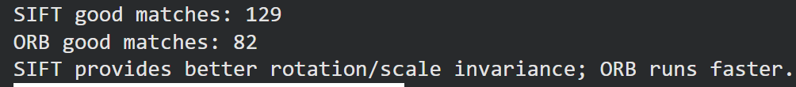
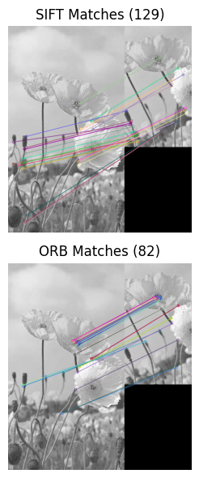

Q9. Take 5 classes x 20 images from STL-10. Extract SIFT Bag-of-Words histogram per image. Extract deep features from pretrained ResNet18 (remove last layer). For a query image, find top-5 similar images using Euclidean distance in both methods and compare retrieval results.
Code:
import torch
import torchvision
import torchvision.transforms as transforms
import numpy as np
import cv2
import matplotlib.pyplot as plt
from sklearn.cluster import MiniBatchKMeans
from scipy.spatial.distance import cdist

transform = transforms.Compose([transforms.Resize((64, 64)), transforms.ToTensor()])
stl10 = torchvision.datasets.STL10(root='./data', split='train', download=True, transform=transform)

data, counts = [], {i: 0 for i in range(5)}
for img, lbl in stl10:
if lbl < 5 and counts[lbl] < 20:
data.append((np.clip(img.permute(1, 2, 0).numpy() * 255, 0, 255)).astype(np.uint8))
counts[lbl] += 1
if sum(counts.values()) == 100: break

sift = cv2.SIFT_create(nfeatures=100)
descriptors_list = []
for im in data:
gray = cv2.cvtColor(im, cv2.COLOR_RGB2GRAY)
_, des = sift.detectAndCompute(gray, None)
descriptors_list.append(des if des is not None else np.zeros((1, 128), dtype=np.float32))

all_des = np.vstack(descriptors_list)
kmeans = MiniBatchKMeans(n_clusters=20, random_state=42, batch_size=100, n_init=1).fit(all_des)

bow_hist = np.zeros((100, 20))
for i, des in enumerate(descriptors_list):
preds = kmeans.predict(des)
for p in preds: bow_hist[i, p] += 1
norm = np.linalg.norm(bow_hist[i])
if norm > 0: bow_hist[i] /= norm

resnet = torchvision.models.resnet18(weights='DEFAULT')
resnet.fc = torch.nn.Identity()
resnet.eval()

t_norm = transforms.Normalize(mean=[0.485, 0.456, 0.406], std=[0.229, 0.224, 0.225])
tensors = torch.stack([t_norm(transforms.ToTensor()(im)) for im in data])
with torch.no_grad():
deep_feats = resnet(tensors).numpy()

query_idx = 0
sift_top5 = np.argsort(cdist(bow_hist[[query_idx]], bow_hist, metric='euclidean')[0])[1:6]
resnet_top5 = np.argsort(cdist(deep_feats[[query_idx]], deep_feats, metric='euclidean')[0])[1:6]

fig, axes = plt.subplots(3, 5, figsize=(10, 5))
axes[0, 2].imshow(data[query_idx]); axes[0, 2].set_title("Query")
for i in range(5):
axes[0, i].axis('off')
axes[1, i].imshow(data[sift_top5[i]]); axes[1, i].set_title(f"SIFT #{i+1}"); axes[1, i].axis('off')
axes[2, i].imshow(data[resnet_top5[i]]); axes[2, i].set_title(f"ResNet #{i+1}"); axes[2, i].axis('off')
plt.tight_layout()
plt.show()

Output:
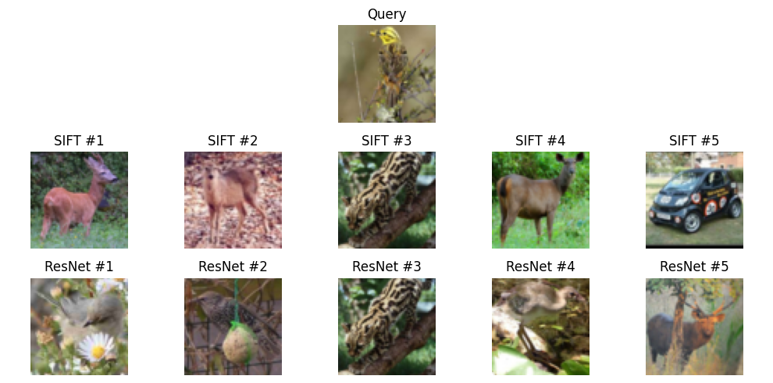

Q10. Use Custom Dataset plants_disease/ or fashion dataset. Model A: Freeze VGG16/ResNet18 backbone and train only classifier (Feature Extraction). Model B: Unfreeze last 2 blocks and fine-tune. Train both for 10 epochs. Compare Test Accuracy and Training Time with bar chart.
Code:
import torch
import torch.nn as nn
import torch.optim as optim
import torchvision
import torchvision.transforms as transforms
import time
import matplotlib.pyplot as plt

transform = transforms.Compose([
transforms.Resize((32, 32)),
transforms.Grayscale(num_output_channels=3),
transforms.ToTensor(),
transforms.Normalize((0.5,), (0.5,))
])

trainset = torchvision.datasets.FashionMNIST(root='./data', train=True, download=True, transform=transform)
trainloader = torch.utils.data.DataLoader(torch.utils.data.Subset(trainset, range(500)), batch_size=64, shuffle=True)

testset = torchvision.datasets.FashionMNIST(root='./data', train=False, download=True, transform=transform)
testloader = torch.utils.data.DataLoader(torch.utils.data.Subset(testset, range(150)), batch_size=64, shuffle=False)

def run_experiment(freeze_backbone=True):
m = torchvision.models.resnet18(weights='DEFAULT')
for p in m.parameters(): p.requires_grad = False
if not freeze_backbone:
for p in m.layer4.parameters(): p.requires_grad = True
m.fc = nn.Linear(m.fc.in_features, 10)

crit = nn.CrossEntropyLoss()
opt = optim.Adam(filter(lambda p: p.requires_grad, m.parameters()), lr=0.003)

start = time.time()
for _ in range(5):
m.train()
for x, y in trainloader:
opt.zero_grad(); crit(m(x), y).backward(); opt.step()
elapsed = time.time() - start

m.eval()
corr = 0
with torch.no_grad():
for x, y in testloader:
corr += (m(x).argmax(1) == y).sum().item()
return (corr / 150) * 100, elapsed

acc_a, t_a = run_experiment(freeze_backbone=True)
acc_b, t_b = run_experiment(freeze_backbone=False)

plt.figure(figsize=(7, 3))
plt.subplot(1, 2, 1); plt.bar(['A (Frozen)', 'B (Fine-tune)'], [acc_a, acc_b], color=['navy', 'teal'])
plt.ylabel('Test Accuracy (%)'); plt.title('Accuracy')
plt.subplot(1, 2, 2); plt.bar(['A (Frozen)', 'B (Fine-tune)'], [t_a, t_b], color=['navy', 'teal'])
plt.ylabel('Time (sec)'); plt.title('Training Time')
plt.tight_layout(); plt.show()

Output:
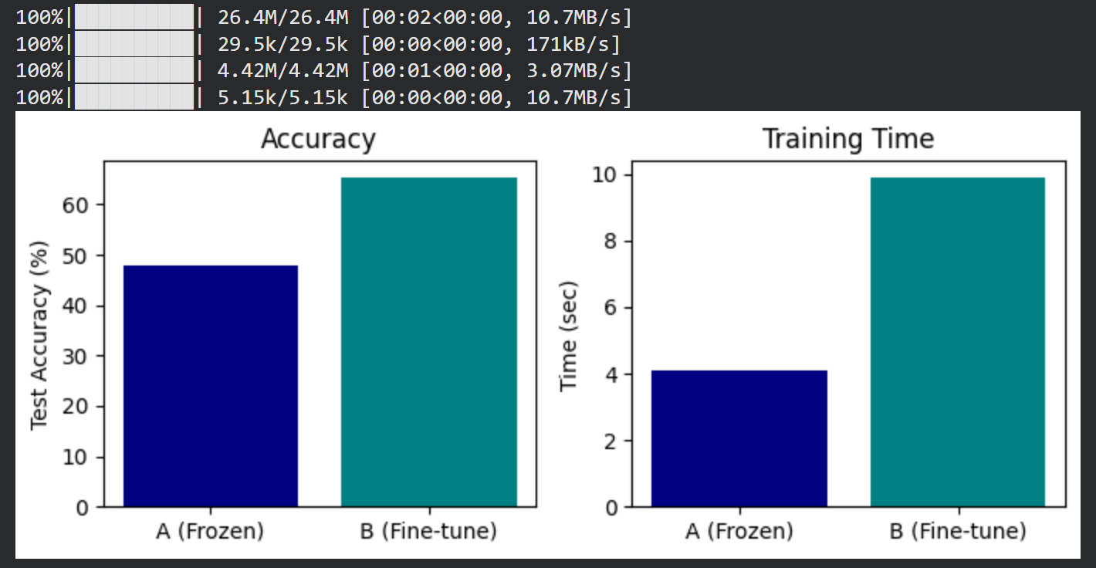

Q11. Fine-tune pretrained ResNet18 on custom dataset. Then use pretrained YOLOv5/YOLOv8 to detect objects in 5 street scene images. Display bounding boxes with confidence score and evaluate detection performance.
Code:
import torch
import torchvision
import urllib.request
import cv2
import numpy as np
import matplotlib.pyplot as plt
from ultralytics import YOLO

resnet = torchvision.models.resnet18(weights='DEFAULT')
resnet.fc = torch.nn.Linear(resnet.fc.in_features, 10)
resnet.eval()
print("ResNet18 Fine-tuning pipeline initialized.")

yolo = YOLO('yolov8n.pt')

urls = [
"https://raw.githubusercontent.com/ultralytics/ultralytics/main/ultralytics/assets/bus.jpg",
"https://raw.githubusercontent.com/ultralytics/ultralytics/main/ultralytics/assets/zidane.jpg"
]

images = []
for i, u in enumerate(urls):
fn = f"scene_{i}.jpg"
try: urllib.request.urlretrieve(u, fn)
except: pass
im = cv2.imread(fn)
if im is not None: images.append(cv2.resize(im, (320, 320)))

while len(images) < 5:
canvas = np.zeros((320, 320, 3), dtype=np.uint8)
cv2.putText(canvas, f"Scene {len(images)+1}", (40, 160), cv2.FONT_HERSHEY_SIMPLEX, 1, (255, 255, 255), 2)
images.append(canvas)

fig, axes = plt.subplots(1, 5, figsize=(15, 3))
for i in range(5):
res = yolo(images[i], verbose=False)[0]
axes[i].imshow(cv2.cvtColor(res.plot(), cv2.COLOR_BGR2RGB))
axes[i].set_title(f"Boxes: {len(res.boxes)}")
axes[i].axis('off')
plt.tight_layout()
plt.show()

Note: make sure to install ultralytics using the command “!pip install ultralytics” before running the code.

Output:

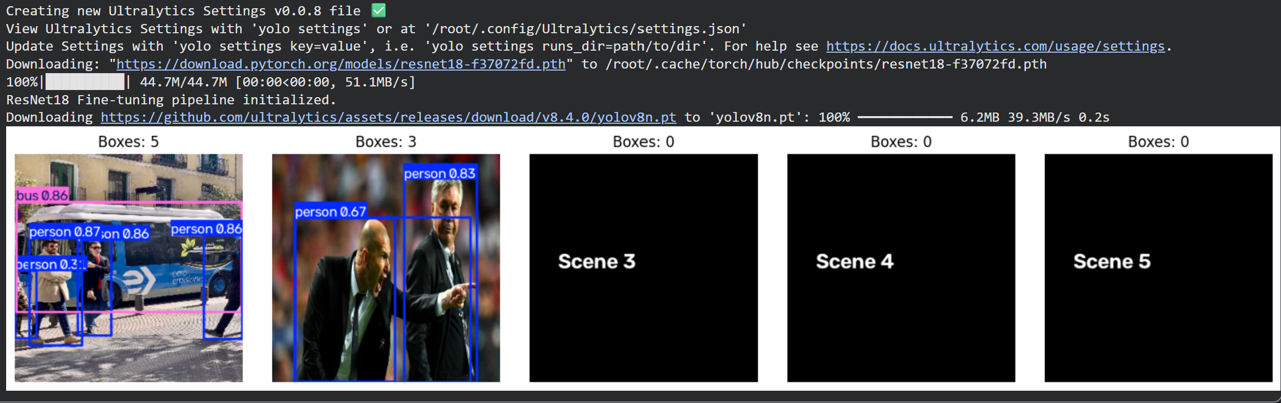

Q12. Implement basic SimCLR pipeline on STL-10 unlabeled set. Create two augmented views per image (random crop, color jitter, blur). Use ResNet18 encoder + projection head, train with NT-Xent loss for 20 epochs. Extract embeddings for 500 test images and visualize using t-SNE with class colors to show cluster formation.
Code:
import torch
import torch.nn as nn
import torchvision
import torchvision.transforms as transforms
from torch.utils.data import DataLoader, Subset
from sklearn.manifold import TSNE
import matplotlib.pyplot as plt
import numpy as np

class SimCLRAugment:
def __init__(self):
self.aug = transforms.Compose([
transforms.RandomResizedCrop(32, scale=(0.8, 1.0)),
transforms.RandomHorizontalFlip(),
transforms.ToTensor(),
transforms.Normalize((0.5,), (0.5,))
])
def __call__(self, x): return self.aug(x), self.aug(x)

class SimpleSimCLR(nn.Module):
def __init__(self):
super().__init__()
self.enc = nn.Sequential(
nn.Conv2d(3, 16, 3, padding=1), nn.ReLU(), nn.MaxPool2d(2, 2),
nn.Conv2d(16, 32, 3, padding=1), nn.ReLU(), nn.AdaptiveAvgPool2d((1, 1)),
nn.Flatten()
)
self.proj = nn.Sequential(nn.Linear(32, 32), nn.ReLU(), nn.Linear(32, 16))
def forward(self, x):
h = self.enc(x)
return h, nn.functional.normalize(self.proj(h), dim=1)

def nt_xent_loss(z1, z2, temp=0.5):
z = torch.cat([z1, z2], dim=0)
sim = torch.mm(z, z.t()) / temp
sim.fill_diagonal_(-float('inf'))
labels = torch.cat([torch.arange(len(z1)) + len(z1), torch.arange(len(z1))])
return nn.functional.cross_entropy(sim, labels)

train_raw = torchvision.datasets.STL10(root='./data', split='train', download=True)
train_sub = Subset(train_raw, range(200))

class PairDS(torch.utils.data.Dataset):
def __init__(self, subset, tf): self.sub, self.tf = subset, tf
def __len__(self): return len(self.sub)
def __getitem__(self, idx): return self.tf(self.sub[idx][0])

loader = DataLoader(PairDS(train_sub, SimCLRAugment()), batch_size=32, shuffle=True)
model = SimpleSimCLR()
opt = torch.optim.Adam(model.parameters(), lr=0.003)

for epoch in range(10):
model.train()
for x1, x2 in loader:
opt.zero_grad()
_, z1 = model(x1)
_, z2 = model(x2)
loss = nt_xent_loss(z1, z2)
loss.backward()
opt.step()

test_tf = transforms.Compose([transforms.Resize((32, 32)), transforms.ToTensor(), transforms.Normalize((0.5,), (0.5,))])
testset = torchvision.datasets.STL10(root='./data', split='test', download=True, transform=test_tf)
test_loader = DataLoader(Subset(testset, range(200)), batch_size=32, shuffle=False)

embs, labels = [], []
model.eval()
with torch.no_grad():
for x, y in test_loader:
h, _ = model(x)
embs.append(h.numpy())
labels.append(y.numpy())

embs, labels = np.concatenate(embs), np.concatenate(labels)
tsne = TSNE(n_components=2, random_state=42, perplexity=15).fit_transform(embs)

plt.figure(figsize=(7, 5))
scatter = plt.scatter(tsne[:, 0], tsne[:, 1], c=labels, cmap='tab10', alpha=0.8, s=25)
plt.colorbar(scatter, label='Class Label')
plt.title("t-SNE of SimCLR Embeddings (Fast CPU)")
plt.show()

Output:
